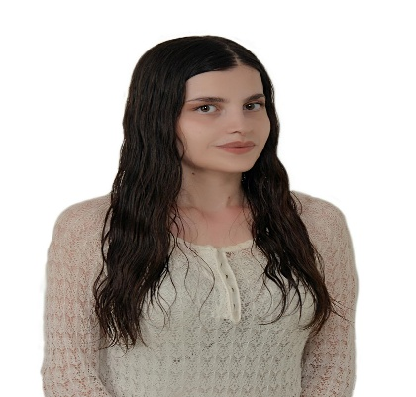Batool Muhammad

Latakia, Syria | +963938603611 | [batoul.mhmmad3@gmail.com](mailto:batoul.mhmmad3@gmail.com) | <https://www.linkedin.com/in/batool-mhmmad-a38441174/Summary>

I am a 23-year-old self-motivated person who always seeks new opportunities and personal growth. I currently work as a Freelance English Content Writer, where I have contributed to the optimization of different websites. I have already written 400+ blog articles about different topics, like traveling, AI, gaming, etc.

# Experience

## Freelancer

### English Content Writer | November 2022, present

* Conduct research related to the content topic.
* Write content about various commercial and service topics.
* Proofread my content and the teams’ articles before submitting.
* Write product description.

## Mints Creative Agency

### Social Media Marketing Intern | April 2022, November 2022

* Manage social media content ( posting, scheduling, replying to messages & comments) .
* Prepare and present weekly and monthly reports.
* Follow up with the marketing team and clients.
* Create copies for different social media platforms.
* Make PowerPoint presentations on various topics related to social media marketing.

## Syriatel Mobile Telecom

## Contact Centre Support Representative | February 2020 – November 2020

* Answer customers' inquiries and provide them with the services they request with excellent quality of service.
* Answer customers' inquiries through phone calls and satisfy their needs around the clock with excellent quality service, good empathy, and accurate information.
* Promote and sell Syriatel products and services.

# Education

Bachelor's Degree in English Language and Literature from Tishreen University, with a grade of 68.33%. | March, 2022

# Soft & Hard skills

* Experienced in using personal computers, office applications such as Microsoft Word, Excel, PowerPoint, and Outlook, and Google Suite tools.
* Experienced in reporting and analyzing data.
* Experienced in using the Internet and social media applications.
* Experienced in computer typing, information research, and fact-checking.
* Familiar with working in high-paced work environments and able to manage time effectively.
* Communicate effectively and candidly.
* Planning and organizational skills.
* Detail oriented and can work efficiently through teamwork and separately.
* Excellent customer service skills.
* Professional presentation skills.
* Familiar with effective problem solving and decision making strategies.
* Fast learner and able to self-teach new tools and software.
* Possess strong collaboration skills and a capacity to adapt to dynamic workplace environments, showcasing flexibility and an ability to navigate change.

# Languages

* Arabic: Native speaker.
* English: Advanced level.